Aaron Templeton

U0734119

Assignment 3 – LU Decomposition

CS 3200

1. See matlab files lupDriver.m, lup.m, bsub.m, fsub.m
2. See matlab file TimingTests.m

2b) here is a plot of time for N = 100 and nrhs = 50

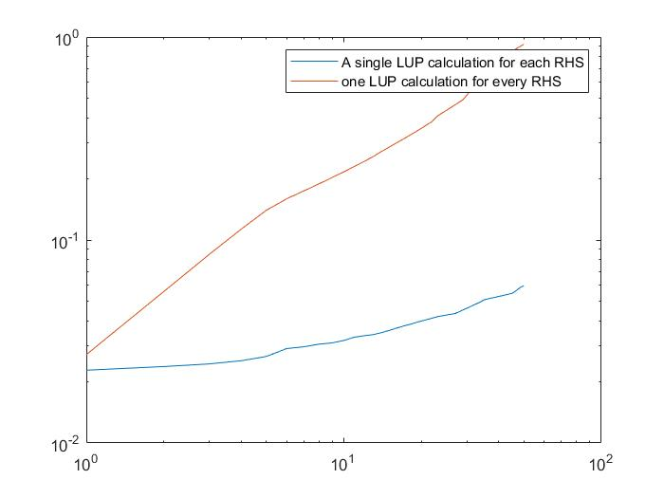 It is much faster to do the LU decomposition one time and compute the right-hand sides from the single LUP than to compute a new LUP for each right-hand side.